Global Life Expectancy Analysis: Econometric Modeling & Comparative Insights

- Introduction & Objectives
This report examines the major factors influence life expectancy across different countries. Using multiple linear regression and hypothesis testing, the analysis focuses on the relationship between life expectancy and a range of health, economic, and social factors.
The main purpose of this study is to identify the factors that have the greatest impact on life expectancy and to compare the average life expectancy of developed and developing countries. This comparison helps highlight the health and socioeconomic inequalities that continue to exist across the world.
- Multiple Regression Analysis
A multiple linear regression model was used to understand how different health, economic, and social variables are related to life expectancy.
Overall Model Fit
The regression model produced an R² value of 0.778, which means that approximately 77.8% of the variation in the life expectancy can be explained by the variables included in the model. This indicates that the model provides a strong explanation of the differences in life expectancy across countries.
The overall regression model was also statistically significant, with an F-statistic p-value of less than 2.2e-16. This suggests that the independent variables, when considered together, have a meaningful relationship with life expectancy.
Key Factors Affecting Life Expectancy
The results show that some factors are positively associated with life expectancy, while others have a negative relationship with it.
Positive factors:
Schooling and Income Composition of Resources have some of the strongest positive effects on life expectancy. In simple terms, countries with better educational opportunities and stronger socioeconomic conditions tend to have higher life expectancy. Education can improve people’s awareness of health, employment opportunities, and overall quality of life, while better access to resources can support improved living conditions.
Negative factors:
Adult Mortality and HIV/AIDS have strong negative effects on life expectancy. Higher adult mortality naturally reduces the average number of years people are expected to live. Similarly, a higher prevalence of HIV/AIDS is associated with lower life expectancy, reflecting the serious impact of disease on population health.
- Model Diagnostics & Assumption Checks
To make sure that the regression results were reliable, diagnostic tests were carried out using R. Multicollinearity diagnostics via VIF showed all values stayed well below threshold limits (ranging from 1.28 to 2.97), indicating independent predictor contributions.

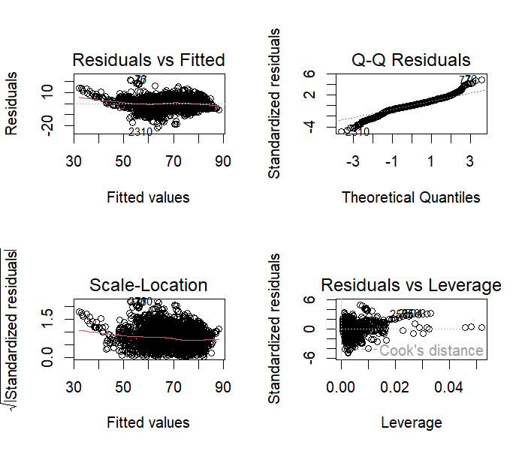

Interpretation of Diagnostic Plots
The Residuals vs Fitted plot was used to check whether the relationship between the variables was reasonably linear and whether the residuals had a constant spread. The pattern of the residuals provides an indication of whether the assumptions of the regression model are being met.
The Normal Q-Q plot was used to examine the distribution of the residuals. Since the points generally follow the reference line, the residuals appear to be reasonably close to a normal distribution. This is particularly useful when making statistical inferences with a relatively large sample.
The Scale-Location plot helps assess whether the variability of the residuals remains relatively consistent across different fitted values. Finally, the Residuals vs Leverage plot helps identify observations that may have unusually high leverage or may have an excessive influence on the estimated regression coefficients.
Overall, the diagnostic plots provide reasonable support for the use of the regression model, although some individual observations may still have greater influence than others.
- Hypothesis Testing: Developed vs. Developing Countries
A Welch Two-Sample t-test was conducted to determine whether there is a statistically significant difference in life expectancy between developed and developing countries, based on the “Status” variable.
The test produced a p-value of less than 2.2e-16. Since this p-value is far below the conventional significance level of 0.05, the null hypothesis is rejected. Therefore, there is strong statistical evidence that the average life expectancy differs between developed and developing countries.

Group Means

- Developed Countries: 79.19 years
- Developing Countries: 67.13 years
The difference between the two groups is approximately 11 years. On average, people in developed countries live around 11 years longer than people in developing countries.
- Conclusion
Overall, the analysis shows that life expectancy is strongly connected to a country’s educational, economic, and health conditions. The regression results suggest that factors such as schooling and access to resources can contribute to longer lives, while adult mortality and HIV/AIDS are associated with significantly lower life expectancy.
The comparison between developed and developing countries further emphasizes the extent of global inequality in health outcomes. With an average difference of around 11 years in life expectancy, the findings highlight how differences in healthcare, education, economic opportunities, and living conditions can have a major effect on people’s lives.
In conclusion, improving education, strengthening healthcare systems, reducing disease burden, and improving access to socioeconomic resources could play an important role in reducing the global gap in life expectancy.

